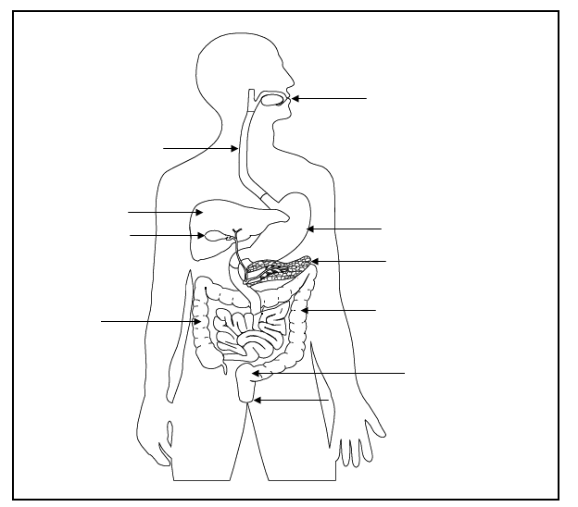

Digestive system

**Anus -** the opening at the end of the digestive system from which faeces (poo) leaves the body.

**Oesophagus** - the long tube between the mouth and the stomach.

**Gall bladder** - a small sac below the liver. It stores and releases bile into the small intestine.

**Large intestine** - the shorter wider tube that follows the small intestine.

**Liver** - a large organ which makes bile that neutralises stomach acid.

**Mouth** - the first part of the digestive system, where food enters the body.

**Pancreas** – a gland below the stomach which makes lots of chemicals called enzymes that help break down food.

**Rectum** - the lower part of the large intestine, where faeces (poo) is stored before it leaves the body.

**Small intestine** - the long, thin winding tube that food goes through after it leaves the stomach.

**Stomach** - a sack-like, muscular organ that is attached to the oesophagus. When food enters the stomach, it is churned with lots of acid.

**Challenge :** Use the descriptions of the digestive organs to correctly label the diagram above.